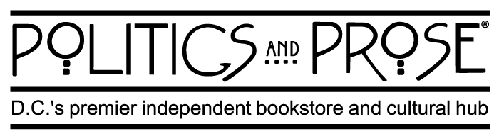

Get your copy of The Infamous Rosalie locally!

POLITICS AND PROSE BOOKSTORE – 3 LOCATIONS

- NORTHWEST DC
  - Directions:
    - 5015 Connecticut Avenue NW Washington, D.C. 20008
  - Store Hours:
    - MONDAY - SATURDAY: 9 a.m. to 8 p.m.
    - SUNDAY: 10 a.m. to 8 p.m.
  - Phone Number: (202) 364-1919
- THE WHARF
  - Directions:
    - 70 District Square SW Washington, D.C. 20024
  - Store Hours:
    - DAILY: 10 a.m. to 8 p.m.
  - Phone Number: (202) 488-3867

- UNION MARKET
  - Directions:
    - 1270 5th Street NE Washington, D.C. 20002
  - Store Hours:
    - MONDAY: CLOSED
    - TUESDAY – SATURDAY: 10 a.m. to 8 p.m.
    - SUNDAY: 11 a.m. to 7 p.m.
  - Phone Number: (202) 544-4452

*Please call beforehand to check book quantity/availability*

